4. Movie

CREATE TABLE Movie (
movie_id INT PRIMARY KEY,
title VARCHAR(100) NOT NULL,
genre VARCHAR(50),
language VARCHAR(30),
duration INT,
release_date DATE
);
INSERT INTO Movie VALUES
(1, 'KGF Chapter 3', 'Action', 'Hindi', 165, TO_DATE('2025-01-10','YYYY-MM-DD'))
INSERT INTO Movie VALUES
(2, 'Pushpa 2', 'Action', 'Telugu', 180, TO_DATE('2025-01-15','YYYY-MM-DD'));
INSERT INTO Movie VALUES
(3, 'Fighter', 'Thriller', 'Hindi', 150, TO_DATE('2025-01-20','YYYY-MM-DD'))
INSERT INTO Movie VALUES
(4, 'Animal', 'Drama', 'Hindi', 200, TO_DATE('2025-01-25','YYYY-MM-DD'));
INSERT INTO Movie VALUES
(5, 'Dunki', 'Comedy', 'Hindi', 160, TO_DATE('2025-02-01','YYYY-MM-DD'));

CREATE TABLE Screen (
screen_id INT PRIMARY KEY ,
screen_type VARCHAR(20),
seating_capacity INT
);

INSERT INTO Screen VALUES (1, 'Dolby Atmos', 200);
INSERT INTO Screen VALUES (2, '3D', 150);
INSERT INTO Screen VALUES (3, '2D', 100);
INSERT INTO Screen VALUES (4, '3D', 180);
INSERT INTO Screen VALUES (5, '2D', 120);
CREATE TABLE Show1 (
show_id INT PRIMARY KEY ,
movie_id INT references Movie(movie_id),
screen_id INT references Screen(screen_id),
show_date DATE,
show_time VARCHAR2(10),
tickets_sold INT DEFAULT 0,
ticket_price DECIMAL(6,2)
);

INSERT INTO Show1 VALUES
(1, 1, 1, TO_DATE('2025-03-01','YYYY-MM-DD'), '10:00:00', 180, 250.00);
INSERT INTO Show1 VALUES
(2, 2, 2, TO_DATE('2025-03-01','YYYY-MM-DD'), '13:00:00', 140, 200.00);
INSERT INTO Show1 VALUES
(3, 3, 3, TO_DATE('2025-03-01','YYYY-MM-DD'), '16:00:00', 90, 150.00);
INSERT INTO Show1 VALUES
(4, 4, 1, TO_DATE('2025-03-02','YYYY-MM-DD'), '18:00:00', 195, 300.00);
INSERT INTO Show1 VALUES
(5, 5, 4, TO_DATE('2025-03-02','YYYY-MM-DD'), '10:00:00', 100, 180.00);

CREATE TABLE Booking (
booking_id INT PRIMARY KEY,
show_id INT REFERENCES Show(show_id),
customer_name VARCHAR(100),
tickets_booked INT,
booking_date DATE,
total_amount DECIMAL(8,2)
);

INSERT INTO Booking VALUES
(1, 1, 'Riya Sharma', 2, TO_DATE('2025-03-01','YYYY-MM-DD'), 500.00);
INSERT INTO Booking VALUES
(2, 2, 'Aman Verma', 3, TO_DATE('2025-03-01','YYYY-MM-DD'), 600.00);
INSERT INTO Booking VALUES
(3, 3, 'Priya Singh', 1, TO_DATE('2025-03-01','YYYY-MM-DD'), 150.00);
INSERT INTO Booking VALUES
(4, 4, 'Karan Mehta', 4, TO_DATE('2025-03-02','YYYY-MM-DD'), 1200.00);
INSERT INTO Booking VALUES
(5, 5, 'Sneha Patel', 2, TO_DATE('2025-03-02','YYYY-MM-DD'), 360.00);

1.We can look up any movie’s details – genre, language,duration, release date
select movie_id, title, genre, language, duration, release_date FROM Movie;

2.we can see every screen’s capacity and type(2D / 3D/ Dolby)
Select screen_id,seating_capacity,screen_type from Screen;
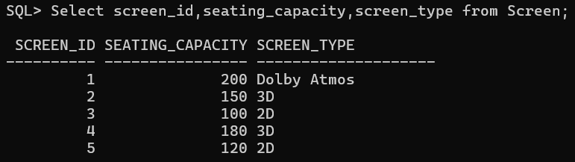

3. We can book tickets and instantly know how many seats are left for a specific show.
Select M.title , S.show_date, S.show_time,SC.seating_capacity, S.tickets_sold, (SC.seating_capacity – S.tickets_sold) AS seats_Available
From Show1 S
JOIN Movie M ON S.movie_id = M.movie_id
JOIN Screen SC ON S.screen_id = SC.screen_id
Where S.show_id = 1;
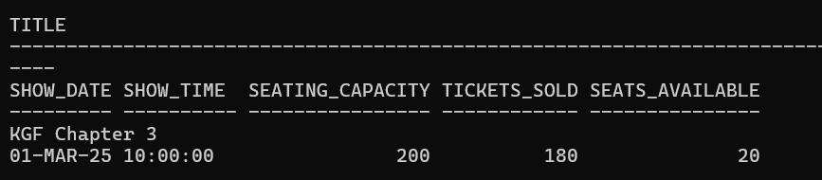

4.We can generate reports like ‘most watched movie this month’.
SELECT M.movie_id,
M.title,
SUM(S.tickets_sold) AS total_tickets
FROM Show1 S
JOIN Movie M
ON S.movie_id = M.movie_id
WHERE EXTRACT(MONTH FROM S.show_date) = 3
AND EXTRACT(YEAR FROM S.show_date) = 2025
GROUP BY M.movie_id, M.title
ORDER BY total_tickets DESC
FETCH FIRST 1 ROW ONLY;

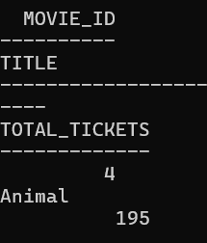

5.today’s total ticket revenue’ in seconds
SELECT M.title,
M.movie_id,
SUM(B.total_amount) AS revenue
FROM Booking B
JOIN Show1 S
ON B.show_id = S.show_id
JOIN Movie M
ON S.movie_id = M.movie_id
WHERE B.booking_date =
TO_DATE('2025-03-01','YYYY-MM-DD')
GROUP BY M.title, M.movie_id
ORDER BY revenue DESC;
